

**NETWORKING&SYSTEM ADMINISTRATION LAB**

**Experiment No.: 22**

**Aim**

Familiarization of basic network commands in windows

**Procedure**

**1. ipconfig**

This commands in windows allows you to see a summarized information of your network such as ip address, subnet mask , server address etc.

**Syntax:** ipconfig

**Output:**

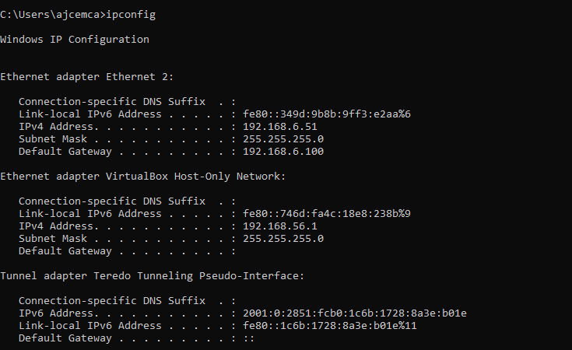

**2. ipconfig/all**

To see the the network information in detail. It is an extension of ipconfig command

**Syntax:-** ipconfig/all

**Output:**

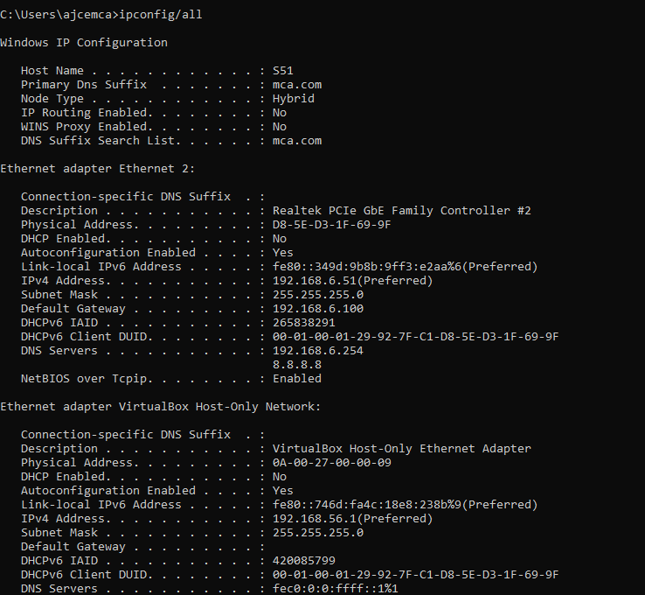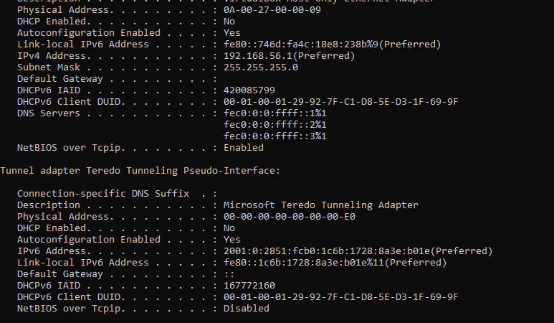

**3.** **nslookup**

To show the server to which the system is connected by default. If we want to find the ip address of a particular domain name, we can also use nslookup

**Syntax:-** nslookup

**Output:**

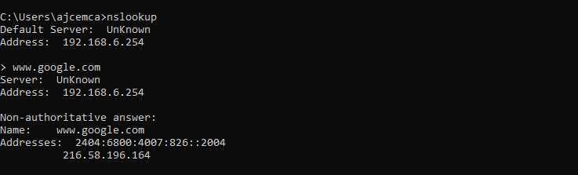

**4. ping**

The command used to check the availability of a host. The response shows the URL you are pinging, the ip address associated with the URL and the size of packets being sent on the first line . The next four lines shows the replies from each individual packets including the time(in milliseconds) for the response and the time to live(TLL) of the packet, that is the amount of time that must pass before the packet discarded.

**Syntax:-** ping URL or ping IP_address

**Output:**

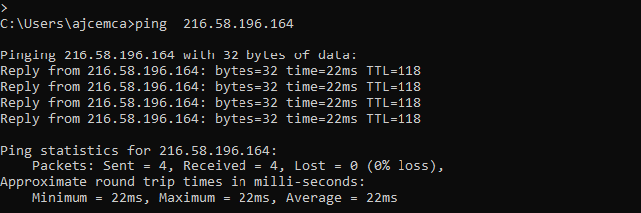

**5. tracert**

The command used to show the packets that are passed through the router to which our system is connected to.

**Syntax:-** tracert <ip_address_of_system>

**Output:**

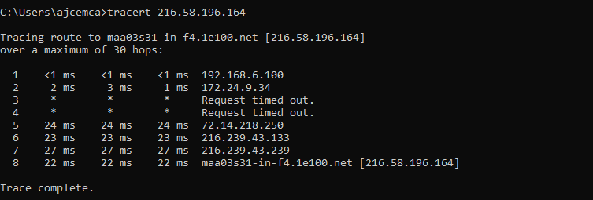

**6. route print**

The command used to display and updates network routing table

**Syntax:-** route print

**Output:**

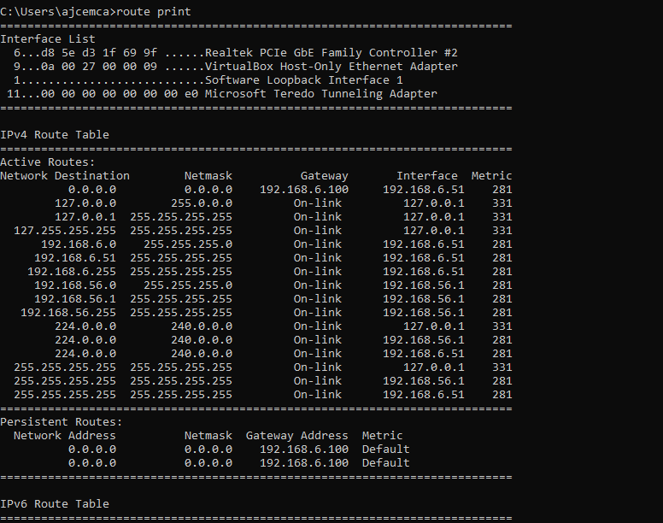

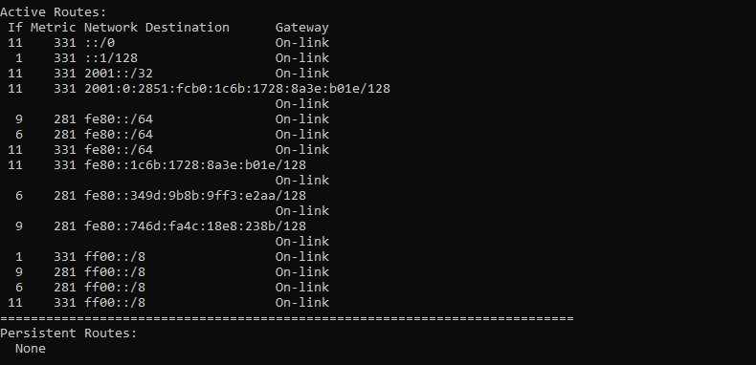

**7. netstat**

The network statistics or netstat command is a networking tool used for troubleshooting and configuration that can also serve a monitoring tool for the connections over the network.

**Syntax:-** netstat

**Output:**

